楚国凯 27720151153561

HW1
- Below is the increase of memory of PCs over the last 40 years。

Year | Byte
1970 | 262144
1971 | 262144
1972 | 262144
1973 | 262144
1974 | 262144
1975 | 262144
1976 | 262144
1977 | 262144
1978 | 262144
1979 | 262144
1980 | 262144
1981 | 262144
1982 | 262144
1988 | 2097152
1989 | 2097152
1990 | 1097152
1991 | 16777216
1992 | 16777216
1993 | 16777216
1994 | 16777216
1995 | 16777216
1996 | 268435456
1997 | 268435456
1998 | 1073741824
1999 | 1073741824
2000 | 1073741824
2004 | 4294967296
2009 | 8589934592
2014 | 17179869184

Logistics Regression
- The goal is to model the probability of a random variable Y being 0 or 1 given experimental data.
- Consider a generalized linear model function parameterized by θ , θT=（θ0，θ1，θ2, ... θn）
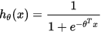
- Outcome
We predict the probability of the outcome occurring; θ₀，θ₁，θ₂, ... θ_{n} can be thought of in much the same way as multiple regression
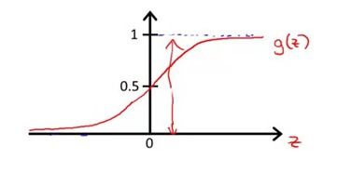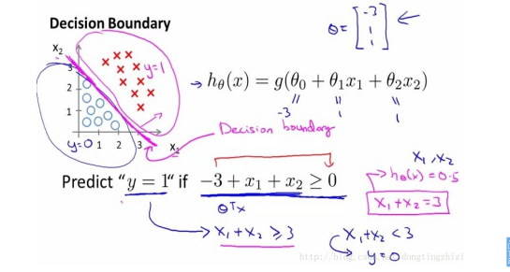
The Log-likelihood statistic
- If we attempt to model the probability that y is 0 or 1 with the function
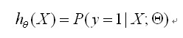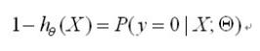
- we take our likelihood function assuming that all the samples are independent,
-Analogous to the residual sum of squares in multiple regression
-It is an indicator of how much unexplained information there is after the model has been fitted.
-Large values indicate poorly fitting statistical models.
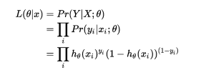

HW2
1、Make an R quantlet to solve HW #1 from unit 1 with R and show it on Github (GH) In [1]: library(readr)
Warning message:
"package 'readr' was built under R version 3.3.3"
In [2]: cpum <- read_csv("cpum.csv",col_names = TRUE)
Parsed with column specification:
cols(
Year = col_integer(),
Byte = col_character()
）
n [3]: par(mfrow = c(1, 1))
- Use R with B-spline code to solve HW#1, any comments?
In [4]: plot(cpum,type="l",xlab = "Year",ylab = "Byte",lwd=2,main = "Memory of Computer")
splines.reg.l1 = smooth.spline(x = cpum$Year, y = cpum$Byte, spar =0.2) # lambda = 0.2 splines.reg.l2 = smooth.spline(x = cpum$Year, y = cpum$Byte, spar =1) # lambda = 1 splines.reg.l3 = smooth.spline(x = cpum$Year, y = cpum$Byte, spar =2) # lambda = 2 lines(splines.reg.l1, col = "red", lwd = 1) # regression line with lambda = 0.2 lines(splines.reg.l2, col = "green", lwd = 1) # regression line with lambda = 1 lines(splines.reg.l3, col = "blue", lwd = 1) # regression line with lambda = 2
- Suppose you observe that in n=1000 mails (in 1 week) you have about 2 scams. Use
the LvB /Poisson cdf to calculate that you have 6 scam emails in 2 weeks. In Scammy and you have 5 scams on average, what is the probability to have no scam mail.
In [5]: lambda=4
x=6
P1=exp(-lambda)*lambda^x/factorial(x)
P1=0.104195634567021
In [6]: lambda=5
x=0
P2=exp(-lambda)*lambda^x/factorial(x)
P2=0.00673794699908547

HW3
1、
In [1]: library("digest")
In [2]: digest("I learn a lot from this class when I am proper listening to the professor", "sha256")
In [3]: digest("I do not learn a lot from this class when I am absent and playing on my Iphone","sha256")
For the ﬁrst sentence,the hash number is "c16700de5a5c1961e279135f2be7dcf9c187cb6b21ac8032308c715e1ce9964c" For the second sentence, the hash number is "2533d529768409d1c09d50451d9125fdbaa6e5fd4efdeb45c04e3c68bcb3a63e"
2、
In [4]: library(jsonlite)
In [5]: json <-
'[
{"Name" : "Mario", "Age" : 32, "Occupation" : "Plumber"},{"Name" : "Peach", "Age" : 21, "Occupation" : "Princess"},
{},
{"Name" : "Bowser", "Occupation" : "Koopa"}
]'
In [6]: data_frame <- fromJSON(json)

data_frame
Name | Age | Occupation
Mario | 32 | Plumber
Peach | NA | Princess
NA | NA | NA
Bowser | 21 | Koopa

In [7]: data_frame$Ranking <- c(3, 1, 2, 4)
data_frame
Name | Age | Occupation | Ranking
Mario | 32 | Plumber | 3
Peach | NA | Princess | 1
NA | NA | NA | 2
Bowser | 21 | Koopa | 4

In [8]: toJSON(data_frame, pretty=TRUE)
[
{
"Name": "Mario",
"Age": 32,
"Occupation": "Plumber", "Ranking": 3
},
{
"Name": "Peach",
"Age": 21,
"Occupation": "Princess", "Ranking": 1
},
{
"Ranking": 2
},
{
"Name": "Bowser",
"Occupation": "Koopa",
"Ranking": 4
}
]
In [9]: write_json(json,path="C:/Users/Aiqing-Jiang/1.json")
In [10]: read_json(path="C:/Users/Aiqing-Jiang/1.json",simplifyVector = FALSE)
- ’[ {"Name" : "Mario", "Age" : 32, "Occupation" : "Plumber"}, {"Name" : "Peach", "Age" : 21, "Occupation" : "Princess"}, {}, {"Name" : "Bowser", "Occupation" : "Koopa"} ]’
3、
3、
In [12]: library(rjson)
In [13]: json_file = "http://crix.hu-berlin.de/data/crix.json"
json_data = fromJSON(file=json_file)
In [14]: crix_data_frame = as.data.frame(json_data)
In [15]: a <- 1:1175
n<-2*a
m <- n-1
In [16]: date <- t(crix_data_frame[m])
price <- t(crix_data_frame[n])
crix_data <- cbind(date,price)
In [17]: ts.plot(price)
In [20]: library(tseries)
In [21]: adf.test(price)
Warning message in adf.test(price):
"p-value greater than printed p-value"
Augmented Dickey-Fuller Test
data: price
Dickey-Fuller = 0.47023, Lag order = 10, p-value = 0.99 alternative hypothesis: stationary
In [22]: acf(price)
In [23]: pacf(price)
In [25]: library(forecast)
In [26]: auto.arima(price)# ARIMA(5,2,0)
Series: price

ARIMA(5,2,0)
 | ar1 | ar2 | ar3 | ar4 | Ar5
Coefficients: | -0.8808 | -0.7101 | -0.5786 | -0.4783 | -0.2543
s.e. | 0.0284 | 0.0359 | 0.0380 | 0.0362 | 0.0286
sigma^2 estimated as 32821: log likelihood=-7761.48
AIC=15534.95 BIC=15565.36
- Digital Signature Algorithm
- The Digital Signature Algorithm (DSA) can be used by the recipient of a message to verify that the message has not been altered during transit as well as ascertain the originator’s identity. A digital signature is an electronic version of a written signature in that the digital signature can be used in proving to the recipient or a third party that the message was, in fact, signed by the originator. Digital signatures may also be generated for stored data and programs so that the integrity of the data and programs may be verified at any later time.
Digital Signature Generation and Verification
- The DSA is used by a signatory to generate a digital signature on data and by a verifier to verify the authenticity of the signature. Each signatory has a public and private key. The private key is used in the signature generation process and the public key is used in the signature verification process. For both signature generation and verification, the data (which is referred to as a message) is reduced by means of the Secure Hash Algorithm (SHA) specified in FIPS 180-1. An adversary, who does not know the private key of the signatory, cannot generate the correct signature of the signatory. In other words, signatures cannot be forged. However, by using the signatory’s public key, anyone can verify a correctly signed message.
DSA Standard
- The Digital Signature Algorithm is a United States Federal Government standard for digital signatures. DSA was proposed by the National Institute of Standards and Technology (NIST) in August 1991 for use in their Digital Signature Standard (DSS), specified in FIPS 186. A minor revision was issued as FIPS 186-1, and the standard was expanded further as FIPS 186-2. DSA , as described in U.S. Patent 5,231,668, is attributed to David W. Kravitz, a former National Security Agency (NSA) employee. The NIST has made this patent available world-wide royalty-free. The standard continues to be revised and updated periodically by NIST.
HW4
- Daily value of indices in the CRIX family
In [1]: library('rjson')
In [2]: json_file = http://crix.hu-berlin.de/data/crix.json
json_data = fromJSON(file=json_file)
crix_data_frame=as.data.frame(json_data)
In [3]: x=crix_data_frame
dim(x)
In [4]: n=dim(x)
a=seq(1,n[2],2)
b=seq(2,n[2],2)
In [5]: date=t(x[1,a])
price=t(x[1,b])
In [6]: crix=data.frame(date,price)
In [7]: load("ecrix.RData")
In [8]: plot(ecrix, type = "l", col = "blue", xaxt = "n",main = " Daily value of indices in the
lines(efcrix, col = "black")
lines(price, col = "red")
lab=seq(1,n[2],365)
axis(1, at = lab, label = names(ecrix)[lab])
- The log returns of CRIX index
- Histogram and QQ plot of CRIX returns
In [10]: hist(ret, col = "grey", breaks = 20, freq = FALSE, ylim = c(0, 25), xlab = "Return")
lines(density(ret), lwd = 2)
x = seq(-4, 4, length = 100)
curve(dnorm(x, mean = mean(ret), sd = sd(ret)), add=TRUE, col = "darkblue", lwd = 2)
In [11]: qqnorm(ret)
qqline(ret, col = "blue", lwd = 4)
- The sample ACF and PACF of CRIX returns
In[13]: par(mfrow = c(2, 1))
libraries = c("zoo", "tseries")
autocorr = acf(ret, lag.max = 20, ylab = "Sample Autocorrelation",
main = "ACF" ,
lwd = 2, ylim = c(-0.3, 1))
autopcorr = pacf(ret, lag.max = 20, ylab = "Sample Partial Autocorrelation")
main = "PACF" ,
ylim = c(-0.3, 0.3), lwd = 2)
- Figure 7:Diagnostic Checking
In [15]: library(TTR)
library(TSA)
library(caschrono)
library(forecast)
In [16]: auto.arima(ret)
Series: ret
ARIMA(1,1,0) with drift
 | ar1 | drift
Cofficients | -0.4695 | 0e+00
s.e. | 0.0257 | 9e-04
sigma^2 estimated as 0.001881: log likelihood=2022.35 AIC=-4038.7 AICc=-4038.68 BIC=-4023.49
In [17]: fit = arima(ret, order = c(2, 0, 2))
In [18]: par(mfrow = c(2, 1))
crix_pre = predict(fit, n.ahead = 30)
#dates = seq(as.Date("31/07/2014", format = "%d/%m/%Y"), by = "days", length = (ret))
length( plot(ret, type = "l", ylab = "Log return", xlab = "Date",
lwd = 1, main = "CRIX returns and predicted values")
lines(crix_pre$pred, col = "red", lwd = 1)
lines(crix_pre$pred + 2 * crix_pre$se, col = "red", lty = 3, lwd = 1)
lines(crix_pre$pred - 2 * crix_pre$se, col = "red", lty = 3, lwd = 1)
HW5
library(RCurl)
library(XML)
library(stringr)
url = paste("http://shakespeare.mit.edu/romeo_juliet/full.html")
#url = paste("http://shakespeare.mit.edu/julius_caesar/full.html")
#url = paste("http://shakespeare.mit.edu/hamlet/full.html")

abs = lapply(url, FUN = function(x) htmlParse(x, encoding = "ANSI"))
clean_txt = function(x) {
cleantxt = xpathApply(x, "//body//text()
[not(ancestor :: script)][ not(ancestor :: style)]
[not(ancestor :: noscript)] " ,xmlValue)
cleantxt = paste(cleantxt, collapse="\n")
cleantxt = str_replace_all(cleantxt, "\n", " ")
cleantxt = str_replace_all(cleantxt, "\r", "")
cleantxt = str_replace_all(cleantxt, "\t", "")
cleantxt = str_replace_all(cleantxt, "<br>", "")
return(cleantxt)
}

cleantxt = lapply(abs,clean_txt)
vec_abs = unlist(cleantxt)

library(NLP)
library(tm)
library(SnowballC)

abs = Corpus(VectorSource(vec_abs))
abs_dtm = DocumentTermMatrix(abs, control = list(stemming = TRUE, stopwords = TRUE, minWordLength = 3,
removeNumbers = TRUE, removePunctuation = TRUE))

dim(abs_dtm)
inspect(abs_dtm)

findFreqTerms(abs_dtm, 3)

removeSparseTerms(abs_dtm, 0.5)
inspect(removeSparseTerms(abs_dtm, 0.5))

library(ggplot2)
library(wordcloud)

freq = colSums(as.matrix(abs_dtm))
wf = data.frame(word=names(freq), freq=freq)
plot = ggplot(subset(wf, freq>50), aes(word, freq))
plot = plot + geom_bar(stat="identity")
plot = plot + theme(axis.text.x=element_text(angle=45, hjust=1))
plot

freq = colSums(as.matrix(abs_dtm))
dark2 = brewer.pal(6, "Dark2")
wordcloud(names(freq), freq, max.words=100, rot.per=0.2, colors=dark2)
1、Romeo and Juliet, Julius Caesar, Hamlet
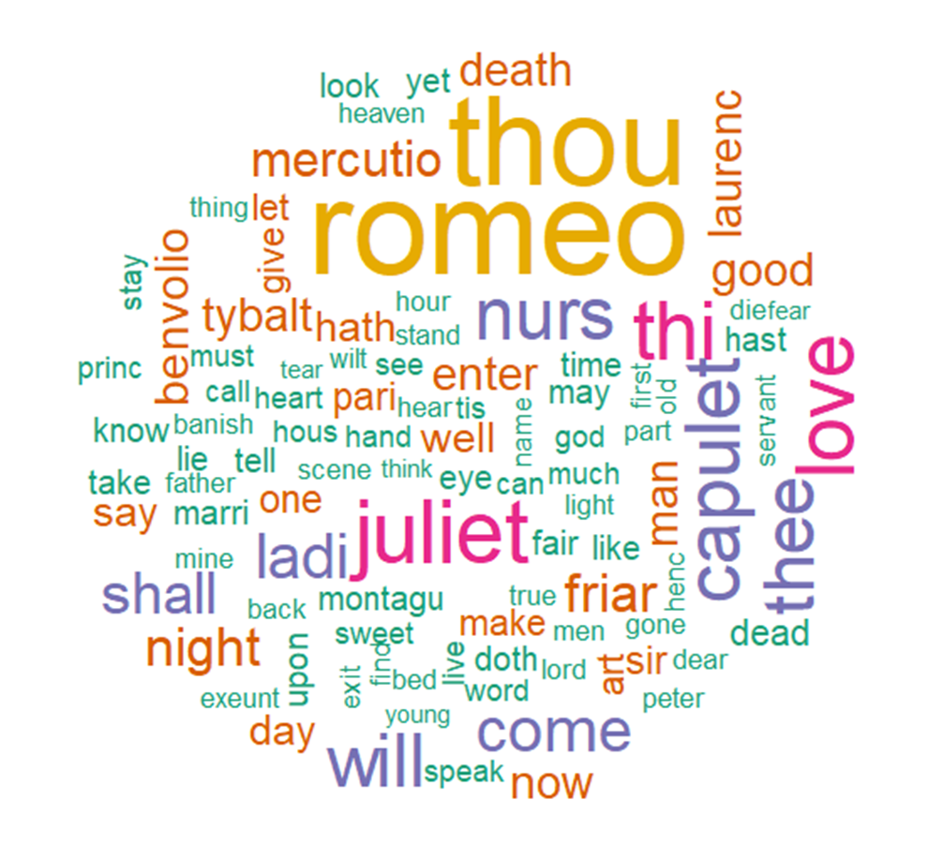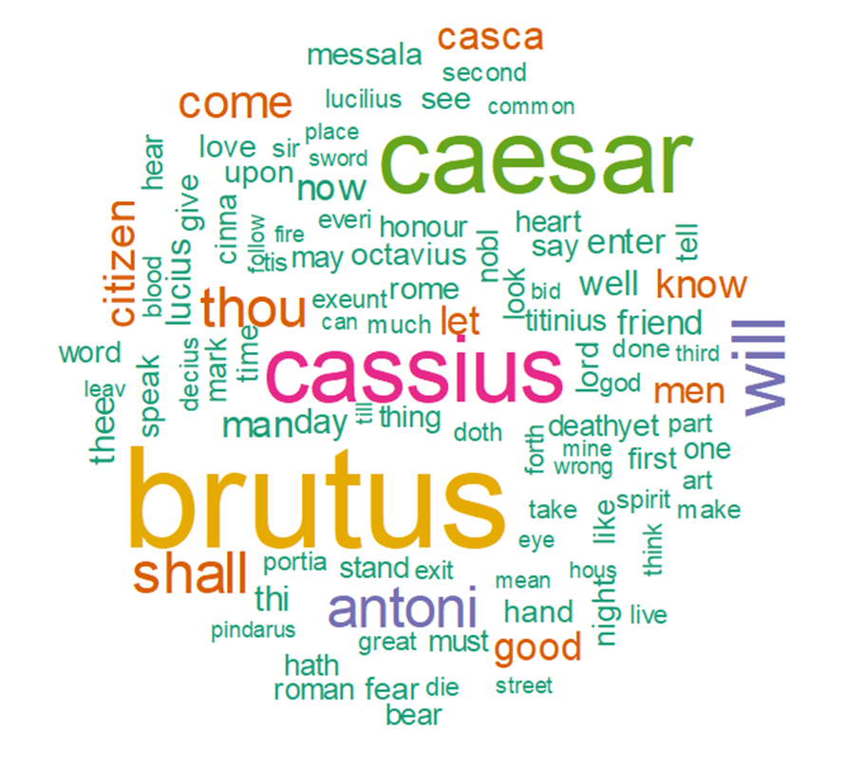
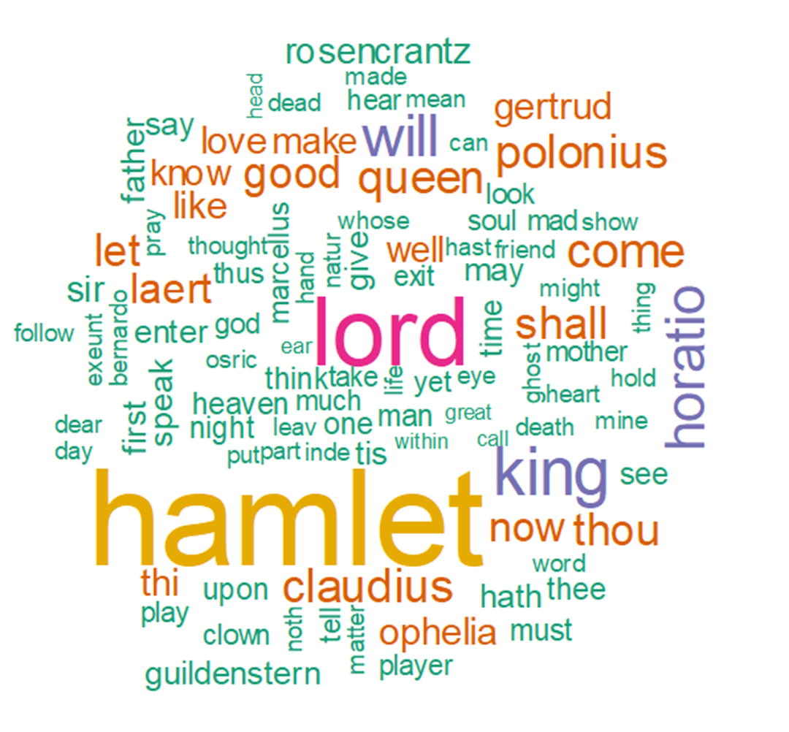

2、Romeo and Juliet, Julius Caesar, Hamlet

